Click to View |  | Label |  | Cat# | Date | Format | Comments | Rating
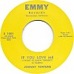 | Johnny Fortune  A: If You Love Me (I Want To Know Tonight)  B: Alone And Cryin' |  | Emmy USA | E-1001 | Sep 1959 | 7" | 1
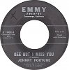 | Johnny Fortune  A: Gee But I Miss You  B: I'm In Heaven (When You Kiss Me) |  | Emmy USA | E-1002 | Apr 1960 | 7" | 1
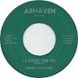 | Johnny Fortune  A: I'm A Fool For You  B: Gee But I Miss You |  | Arhaven USA | A1001 | 1962 | 7" | 0
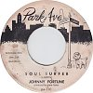 | Johnny Fortune  A: Soul Surfer  B: Midnight Surf |  | Park Ave USA | PA-110 | Jan 1963 | 7" | 2
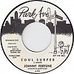 | Johnny Fortune  A: Soul Surfer  B: Midnight Surf |  | Park Ave USA | P-101 | Apr 1963 | 7" | 2
 | Johnny Fortune  A: Surfer's Trip  B: Soul Traveler |  | Park Ave USA | PA-103 | Jun 1963 | 7" | 2
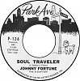 | Johnny Fortune  A: Soul Traveler  B: Surfers Trip |  | Park Ave USA | P-126 | Aug 1963 | 7" | 1
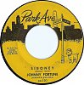 | Johnny Fortune  A: Siboney  B: Dragster |  | Park Ave USA | PA-130 | Nov 1963 | 7" | 5
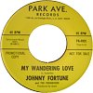 | Johnny Fortune And The Paramours  A: My Wandering Love  B: I'm Talkin' |  | Park Ave. USA | PA-4905 | 1964 | 7" | 0 | 4.0
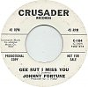 | Johnny Fortune  A: Gee But I Miss You  B: If You Love Me |  | Crusader USA | C-104 | May 1964 | 7" | 0
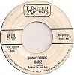 | Johnny Fortune  A: Juarez  B: It Ain't Necessarily So |  | United Artists USA | UA 720 | May 1964 | 7" | 0
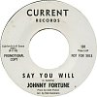 | Johnny Fortune  A: Say You Will  B: Come On And Love Me |  | Current USA | 101 | Oct 1964 | 7" | 5
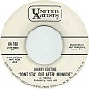 | Johnny Fortune  A: Don't Stay Out After Midnight  B: Don't You Lie To Me |  | United Artists USA | UA 780 | Nov 1964 | 7" | 1
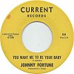 | Johnny Fortune  A: You Want Me To Be Your Baby  B: Don Stole My Girl |  | Current USA | 104 | 1965 | 7" | 7
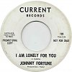 | Johnny Fortune  A: I Am Lonely For You  B: I'll Never Let You Go |  | Current USA | 105 | 1965 | 7" | 4
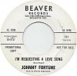 | Johnny Fortune  A: I'm Requesting A Love Song  B: Stay Just One More Day |  | Beaver [Los Angeles] USA | 111 | May 1966 | 7" | 3
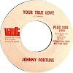 | Johnny Fortune  A: Your True Love  B: Tell Me You Love Me |  | Vault USA | V-954 | 1969 | 7" | 0
Acetates, Bootlegs, Curios
Click to View |  | Label |  | Cat# | Date | Format | Comments | Rating
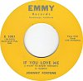 | Johnny Fortune  A: If You Love Me (I Want To Know Tonight)  B: Alone And Cryin'

