APPLE UK | APPLE GERMANY |  | ✓ | PS AS | FIRST ISSUE | ARTIST | TITLE | REMARKS
1 | Not issued |  |  |  | Not issued
2 | O 23 888  Black label  O 23 888  Apple Label A5  O 23 888  Apple Label A7 | 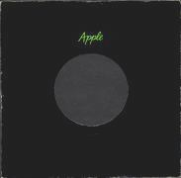 |  | AS | 30.08.1968 | Mary Hopkin | Those Were The Days  Turn! Turn! Turn!  (To Everything There Is A Season) | Released on the same day as Hey Jude, Mary Hopkin a young Welsh singer who had appeared on a British TV talent show called Opportunity Knocks, Paul McCartney saw her and thought she would be ideal for the new label. Mary indeed proved to be one of Apple's most successful artists. The A side was a great launch pad for Mary's young voice while the B-side is in fact a cover version of the Byrds song. Both tracks were produced by Paul. Again it was issued in the UK in a plain black Apple sleeve.  Composed by Gene Raskin - Produced by Paul McCartney - [05:08]  Composed by Pete Seeger - Produced by Paul McCartney [02:50]
2 | Not issued |  |  |  | 25.10.1968 | Mary Hopkin | Quelli Erano Giorni  Turn! Turn! Turn!  (To Everything There Is A Season) | Italy Only
2 | Not issued |  |  |  | 25.10.1968 | Mary Hopkin | En Aquellos Dias  Turn! Turn! Turn!  (To Everything There Is A Season) | Spain Only
3 | O 23 891  Black label  O 23 891  White Label |  |  | MS | 25.09.1968 | Jackie Lomax | Sour Milk Sea  The Eagle Laughs At You | The third single to appear on the label was by a singer from Liverpool who was a close friend of George Harrison. The A side was written by George during the notorious white album sessions, and George produces both the sides of the disc. One of the talented acts that Apple signed however he proved not to be not one of Apples most succesful despite promotions on his behalf by Paul, George and Ringo. He failed to break through to the big time during his time at Apple. Issued in a plain black Apple sleeve.
4 | O 23 927  Black Label |  |  | AS | 06.09.1968 | John Foster & Sons Ltd. Black Dyke Mills Brass Band | Thingumybob  Yellow Submarine | Issued the same day as the Jackie Lomax single this and the previous 3 records were put together in a press kit along with some publicity sheets it was called "Our First Four", nowadays these are very sort after by Apple collectors fetching hundreds of pounds. This single produced by Paul McCartney has a Lennon/McCartney track on the A side (although it was more of a Paul track than a joint effort)which was not recorded by The Beatles or Paul thus making it a must for collectors. A cover version of the Beatles song on the flip side. The Black Dyke Mills Band was a brass band from the North of England and this was their only Apple release. Issued in a plain Apple sleeve.
5 | O 23 965  Apple Label A1  1C006-02 396  Apple Label A1 |  |  | AS | 15.11.1968 | Iveys | Maybe Tomorrow  And Her Daddy's A Millionaire | A world class band signed up to Apple under the name The Iveys, however it was not until they changed their name to Badfinger did they finally make it. Maybe Tomorrow was the first Apple single for the band but even this shows what great talent there was in the band and the song writing partnership of Ham and Evans. Produced by Tony Visconti this single is a sign of the great things to come for the band. Issued in a plain Apple sleeve.
6 | 1C 006-90 020 |  |  | AS | 24.01.1969 | White Trash | Road To Nowhere  Illusions | The first of two singles issued on Apple by this band. Original issues of the singles show the name White Trash however the BBC put pressure on Apple and the band to change their name to Trash, as White Trash was deemed to offend people. Another talented group who saw the big time pass them by while they were signed to Apple. The A side written by Goffin and King and both sides produced by the drummer from the UK group The Shadows, Tony Meehan. Once again issued in a plain Apple sleeve.
7 | Not issued |  |  |  | 07.03.1969 | Mary Hopkin | Lontano Dagli Occhi  The Game | Italy Only  Apple 7 has never officially been released in the UK, however this single appeared in many other countries such as Italy and Brazil with this catalogue number, which makes it safe to assume that the UK release (had there been one) would have also taken the same number.It also appeared in Spain on the Odeon label The B-side written by George Martin would appear a second time on an unissued UK Apple record later. See APPLE9.
8 | Not issued |  |  |  | 16.05.1969 | Brute Force | King Of Fuh  Nobody Knows | DJ Promo  King of Fuh (pronounced fu) is one of the most collectable singles from the Apple collection however it was never released onto the general public. It was obviously a bit of a hot potato for Apple due to its lyrical content, such as "In this land of Fuh there was a king, and they called him the fuh-king" It would never have been played on the radio and would have been instantly banned. The B-side is a much tamer track and is quite commercial for its time. However only promo copies were made.
9 | Not issued |  |  |  | 07.03.1969 | Mary Hopkin | Prince En Avignon  The Game | France Only  The second Mary Hopkin single issued by Apple and aimed primarily at the European market. It was issued in several countries on Apple 9. The George Martin track The game is on the B-side and makes it second appearance on a single never released in the UK
10 | 1C006-90 099  Apple Label A1  1C006-90 099  Apple Label A1a  Apple 10 on label |  |  | AS  AS | 28.03.1969 | Mary Hopkin | Goodbye  Sparrow | A new release from Mary Hopkin destined for the UK charts came in the form of Apple 10. Again the McCartney songwriting skills are lent to another artist (although it is shown as a Lennon/McCartney track) on the A-side. While the B-side has a track written by Gallagher & Lyle. Paul produced both side of the single. Issued in the UK with a plain Apple sleeve it appeared in some European countries with a picture sleeve of Mary sitting against a school blackboard.
11 | 1C006-90 218  Apple Label A1  Musterplatte 1C006-90 218 |  |  | AS  MS | 09.05.1969 | Jackie Lomax | New Day  I Fall Inside Your Eyes | The second Apple single of Jackie Lomx's career. Both sides of the record were written by Jackie. The B-side was lifted from his 1969 album "Is this what you want", the A-side was added to the album as a bonus track during the 1991 re-issues. The A side was produced by Jackie and Beatles roadie Mal Evans and the B-side was produced by George Harrison. Jackie formally with the Liverpool band The Undertakers used Billy Kinsley the bassist with The Merseybeats, Tim Renick on guitar, Chris Hatfield on piano and Pete Clark on drums. The US version of the album was delayed so the track could replace "How can you say goodbye".
12 | 1C006-90 361  Apple Label A1  Musterplatte  1C006-90 361 | 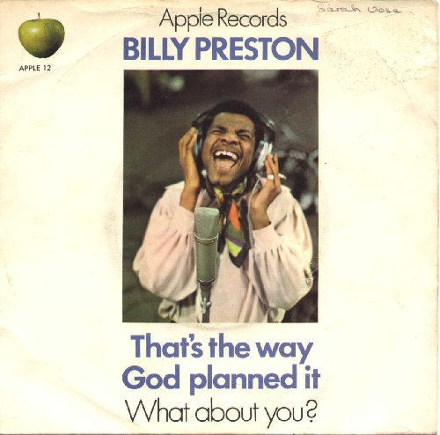 |  | PS  MS | 16.07.1969 | Billy Preston | That's The Way God Planned It  What About You? | Another success for Apple, after Billy Preston arrived at the studios to play with the Beatles during the filming of Let it be, he was also the first and only person to be credited on a Beatles single "Get Back". George produced the A and B sides of this self penned Preston single. Which achieved chart success. George then went on to produce Billy's album too. Issued in a picture sleeve.
13 | 1C006-90 372  Apple Label A1  Second Cover  Label A5  1C006-90 372  Third Cover  Label A6  1C006-90 372  Fourth Cover  Label A6  1C006-90 372 | 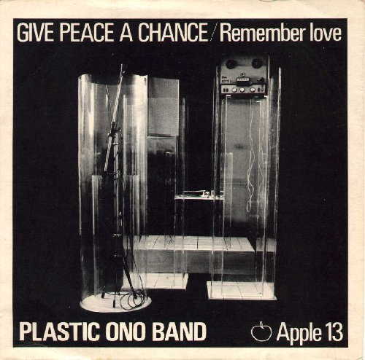 |  | PS 1  PS 2  PS 3  PS 4 | 04.07.1969 | John Lennon  Yoko Ono | Give Peace A Chance  Remember Love | Really this is the first solo Apple record by a Beatle John and his new wife formed the Plastic Ono Band, Again the A side is credited to Lennon/McCartney however Paul had no hand in writing it. The single was recorded during John and Yoko's bed in at room 1742 Hotel La Reine Elizabeth in Montreal Canada.The B side is a song written by Yoko. Issued in a picture sleeve.
14 | 1C006-90493  Apple Label A1 |  |  | AS | 18.07.1969 | Iveys | Dear Angie  No Escaping Your Love | EU & J Only
15 | 1C006-90 587  Apple Label A1  Musterplatte  1C006-90 587 | 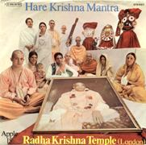 |  | PS  MS | 29.08.1969 | Radha Krishna Temple  (London) | Hare Krishna Mantra  Prayer To The Spiritual Masters | The Hare Krishna's often seen marchign up and down London's busy Oxford Street became Apple recording artists thanks to George Harrison who is a follower of the religion. This single consists of traditional mantras and prayers that the Krishna's chant, Both produced by George. Issued with a picture sleeve.
16 | 1C006-91 624  Apple Label A1 | 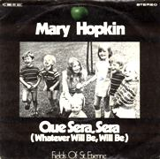 |  | PS | 19.09.1969 | Mary Hopkin | Que Sera, Sera (Whatever Will Be, Will Be)  Fields Of St. Etienne | Germany & France only  The first of two attempts to issue this Mary Hopkin recording in the UK as a single, neither of which happened. There have also been claims that APPLE16 was earmarked for the band Mortimer's single of "On our way home", however there has been no evidence for that release discovered.
17 | 1C006-90693  Apple Label A1  Musterplatte 1C006-90693 |  |  | AS  MS | 03.10.1969 | Trash | Golden Slumbers/Carry That Weight  Trash Can | The second and final Apple single from the band. This time the A-side was a Lennon/McCartney track from the forthcoming Beatles Album Abbey Road (due to be released 6 days later). The backing in places sounds very similar to Beatles version and it could be that they used the Beatles backing. A good record all round. The single was once again produced by Shadows drummer Tony Meehan.
18 | Not issued |  |  |  | 10.10.1969 | Hot Chocolate Band | Give Peace A Chance  Living Without Tomorrow | Another first for Apple, the Hot chocolate band is in fact the same band as Hot chocolate, the same band that is around today, their first record was a cover version of John and Yoko's Give peace a chance. Erol Brown the lead singer of the band was a friend of John's. The A-side is a reggae version of the single and some of the lyrics have been altered, leaving some of the rhymes a bit stretched but another must for Apple collectors. Brown also co-wrote the B-side. Issued in a plain Apple sleeve.
19 | 1C006-90 720  Apple Label A1  Musterplatte  1C006-90 720 |  |  | PC  MS | 04.11.1969 | Billy Preston | Everything's All Right  I Want To Thank You | The second single from Billy's sucessful debut Apple album. The A-side was co written by Billy and another future Apple recording artist Doris Troy. While the B-side was written soley by Preston. Produce by George Harrison, who expressed in the Anthology shows that when Billy arrived at the Let it be sessions it helped to smooth things over between the Beatles for a short while. Issued in a plain Apple sleeve.
20 | 1C006-90 916  Apple Label A1  1C006-90 916  Musterplatte  1C006-2046527  EEC Label A7 |  |  | AS  MS  PS | 05.12.1969  1992 | Badfinger | Come And Get It  Rock Of All Ages | The title music to the film Magic christian starring Ringo and Peter Sellers, which was written by Paul McCartney proved to be a top ten hit for the group who had just undergone a minor line up change. The B-side is a song written by the group and was also used in the film. Issued in a picture sleeve.
21 | 1C006-91 161  Apple Label A1  Musterplatte  1C006-91 161 | 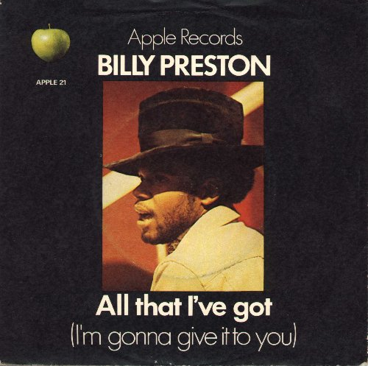 |  | PS  MS | 30.01.1970 | Billy Preston | All That I've Got (I'm Gonna Give It To You)  As I Get Older | Another Preston/Troy collaboration graces the A-side of this great single. Once again the A-side is produced by George Harrison who seemed to have taken Billy under his wing. The B-side is another first for Apple as the legendary Ray Charles produced this instrumental collaboration between Preston and Stewart. It was also the first Apple record to bear the legend PLAY LOUD on the label of both sides of the single. Issued in a picture sleeve.
22 | 1C006-91 098  Apple Label A1 | 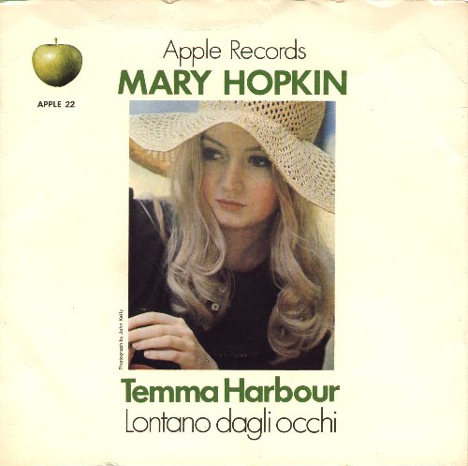 |  | PS | 16.01.1970 | Mary Hopkin | Temma Harbour  Lontano Dagli Occhi | Mary Hopkin was obviously becoming one of Apple's stars as the ammount of records that she was releasing on the label clearly shows. By now she had teamed up with producer Mickie Most who produced the A side. The B side was the track originally lined up for Apple 7 and it gets its first official issue here. Issued in a picture sleeve.
23 | 1C006-91 115  Apple Label A1  Musterplatte  1C006-91 115 | 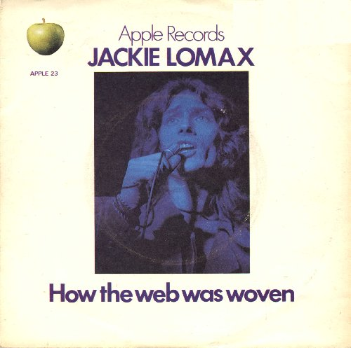 |  | PS  MS | 06.02.1970 | Jackie Lomax | How The Web Was Woven  Thumbin' A Ride | Jackie's last single issued by Apple was a song selected by George Harrison who produced it and was written by Clive Westlake and David Most. The B-side Thumbin' a ride was written by the great song writing team of Leiber and Stoller. The B-side produced by another Beatle Paul McCartney.It was issued in a picture sleeve.
24 | Not issued |  |  |  | 13.02.1970 | Doris Troy | Ain't That Cute  Yaya Con Dios | Doris Troy's first Apple single is a collaboration between Doris Troy and George Harrison. Doris had previously been known for her work with Billy Preston. THe A side produced by George shows he obviously had a huge respect for her style. The B side is a song with a Spanish title which when translated means God go with you my love. Issued in a picture sleeve.
25 | 1C006-91 253  Apple Label A1 | 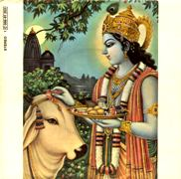 |  | PS | 06.03.1970 | Radha Krishna Temple (London) | Govinda  Govinda Jai Jai | The second of two singles from the Radha Krishna temple again produced by George Harrison. This single proved to be popular that it made the charts and the Radha Krishna temple made 2 appearances on Top of the pops to promote it. As with their last single both sides are traditional chants and prayers the Krishna's use daily. Issued with a picture sleeve.
26 | 1C006-91 312  Apple Label A1 | 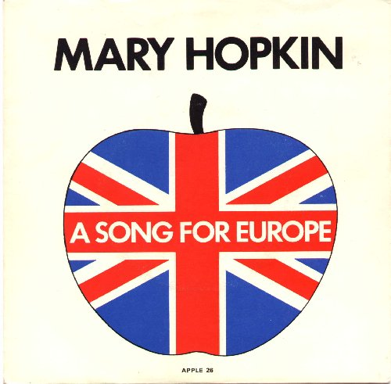 |  | PS | 20.03.1970 | Mary Hopkin | Knock, Knock, Who's There?  I'm Going To Fall In Love Again | The British entry in the Eurovision song contest for 1970 came in the form of Mary Hopkin and Apple released the single of the song, sadly Mary came second in the competition but the record proved a great success and hit the top ten. Both sides produced by Mickie Most again. It was issued in a picture sleeve with variations of the sleeve issued in Europe.
27 | Not issued |  |  |  | Not Issued | Jacky Lomax | Going Back To Liverpool  Won't You Come Back | A second attempt to release this Mary Hopkin track, once again it failed to be issued. It is likely that Apple 27 was purely for the UK market as the single had been released in some European countries as APPLE16.
28 | 1C006-91 818  Apple Label A1  Musterplatte  1C006-91 818 | 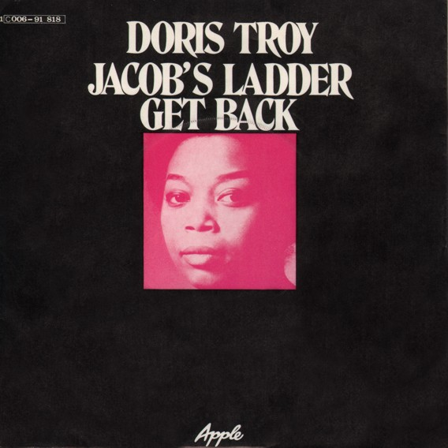 |  | PS  MS | 28.08.1970 | Doris Troy | Jacob's Ladder  Get Back | Doris Troy's second Apple single was a real Beatle affair. The A side a traditional song was co-arranged by George Harrison along with Doris, while the B-side is a cover version of the Beatles song. There must be many hours of unreleased material by Apple recording artists who had one or more of the Beatles playing on their tracks. This single was produced by Doris and was issued in a plain Apple sleeve.
29 | Not issued |  |  |  | 04.09.1970 | Billy Preston | My Sweet Lord  Long As I Got My Baby | WDRN  Billy Preston's recording of the future George Harrison hit, was not released in the UK despite Apple29 being reserved for it, some European countries issued the single with this number. The B side was until recently unreleased making the single a real must for collectors of the label.
30 | 1C006-91 883  Apple Label A1 | 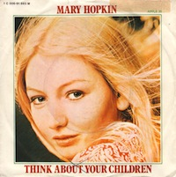 |  | PS | 16.10.1970 | Mary Hopkin | Think About Your Children  Heritage | Seven months after the release of Knock Knock who's there, another Mary Hopkin single is issued. This time the A side is written by a collaboration between Tony and Margaret Wilson and Errol Brown from Hot chocolate, the B side is a Gallagher and Lyle track produced by Mickie Most. Issued in a picture sleeve.
31 | 1C006-92 064  Apple Label A1  1C006-92 064  Musterplatte | 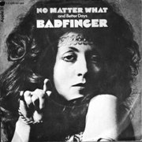 |  | PS  PS | 06.11.1970 | Badfinger | No Matter What  Better Days | Both sides of this single were lifted from the new Badfinger album No Dice. Fourteen months after their last single No mater what came back and showed the world that Badfinger were still around and gave the band another top ten hit the world over. The A side written by Pete Ham and produced by Beatles roadie Mal Evans while the B side written by Tom Evans and Joey Molland (not Holland as the label suggests) produced by Beatles recording engineer Geoff Emerick. Issued in a picture sleeve.
32 | Not issued |  |  |  | 06.11.1970 | James Taylor | Carolina In My Mind  Something's Wrong | APPLE32 is a bit of a mystery, James Taylor was one of the first Apple artists to be signed to the label and had an album out in the first year, however no single was every taken from it, over 2 years later the album is re-issued on Apple and the single is taken from it, the only other 45 release from Taylor on Apple was part of the Walls EP where the B-side of this single was issued. Both tracks written by James Taylor. Issued in a plain Apple sleeve.
33 | Not issued |  |  |  | 16.04.1971 | Ringo Starr | It Don't Come Easy  Early 1970
33 | 1C006-92 470  Apple Label A1 | 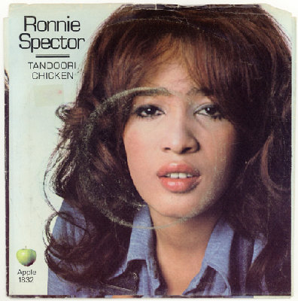 |  | PS | 16.04.1971 | Ronnie Spector | Try Some, Buy Some  Tandoori Chicken | Formerly from the girl band The Ronnettes, Ronnie Spector released a single on Apple. The A side was a George Harrison track that would later appear on his album Living in the material world. The B side is a joint effort between George and Phil Spector (Ronnie's husband), it does not appear on any other release making this a must have single for Harrison/Spector and Apple collectors alike.Produced by George and Phil. It was issued in a picture sleeve.
34 | 1C006-92 640  Apple Label A1 | 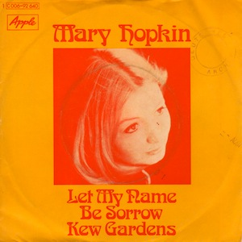 |  | PS | 18.06.1971 | Mary Hopkin | Let My Name Be Sorrow  Kew Gardens | Mary Hopkin's first release of this year, sees her with a new producer. After losing Mickie Most the single was produced by Tony Visconti (whom she later married). Mary was fast becoming Apple's best selling artist as the ammount of records she issued shows. The B side was written by Ralph McTell better known for the song Streets of London which Mary covered for her album Earth Song Ocean Song. Issued in a picture sleeve.
35 | Not issued |  |  |  | Not Issued | Badfinger | Name Of The Game (remix)  Suitcase | Seven months after Badfinger's last release No matter what, the projected follw up single was rejected by Apple's A & R man Phil Spector. The name of the game never made it to be pressed as a single in the UK. However to add confusion to the Apple story there have been some demo's issued with Nicky Thomas singing Only a child / Love thy neighbour with the same catalogue number indicating that the full story of Apple35 has yet to come out.
36 | Not issued |  |  |  | 16.07.1971 | Bill Elliott  Elastic Oz Band | God Save Us  Do The Oz | Alternative magazine Oz was in leagal trouble and was taken to court of it's "schoolkids" issue. To raise money for the magazine's legal costs, John and Yoko wrote both sides of this record. The A side was produced by John, Yoko, Phil Spector and Mal Evans, although he was not included in producing the B side. The single did not sell very well, and did not earn the campaign much money. Issued in a picture sleeve.
37 | Not issued |  |  |  | 27.08.1971 | Ravi Shankar | Joi Bangla  Oh Bhaugowan  Raga Mishra  Jhinjhoti | Ravi Shankar was George Harrison's mentor, he helped him study the Sitar which George was very keen to introduce to not only his solo music but the Beatles too. This was Ravi's only Apple single (in fact it is a mini EP with 3 tracks on it). Although he did have an LP on the label too and was later recorded and issued through George's own Dark Horse record label. Produced by George this single came in a picture sleeve.
38 | 1C006-92 940  Apple Label A1 | 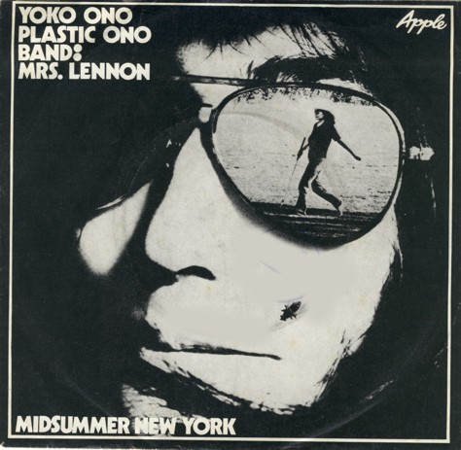 |  | PS | 29.10.1971 | Yoko Ono | Mrs. Lennon  Midsummer New York | Yoko Ono is the only Beatle wife to have a solo record issued by Apple. The label itself although still having an apple shape had a picture of Yoko while the B-side showed a black and white picture of the cut apple. Both sides written by Yoko and it was produced by John and Yoko. Issued in a plain apple sleeve.
39 | Not issued |  |  |  | 03.12.1971 | Mary Hopkin | Water, Paper And Clay  Jefferson | Taken from Mary's album Earth Song/Ocean Song, this would be the last single on the Apple label. The A-side written by Reina and Mike Sutcliffe while the B-side was written by Gallagher and Lyle. Once again the single was produced by her (to be) husband Tony Visconti. APPLE39 was issued in a now hard to find picture sleeve.
40 | 1C006-93 159  Apple Label A1 | 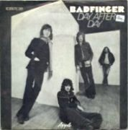 |  | PS | 14.01.1972 | Badfinger | Day After Day  Sweet Tuesday Morning | Badfinger was definitely one of Apple's biggest success stories. This single was taken from the album Straight Up. The A-side written by Pete Ham and the B-side by Joey Molland. The A-side was produced by George Harrison and the B-side by Todd Rundgren. Issued in a picture sleeve.
41 | Not issued |  |  |  | 21.01.1972 | Yoko Ono | Mind Train  Listen, The Snow Is Falling | Edit  Yoko's second single issued on Apple. once again it featured the altered Apple label. Both sides written by Yoko with the A-side produced by John and Yoko, the B-side was also co-produced by Phil Spector. This has now become one of the more common Apple singles issued as a large supply of mint copies were found in a New York wharehouse a few years ago. Issued in a picture sleeve.
42 | 1C006-93 391  Apple Label A1  1C006-93 391  different bc | 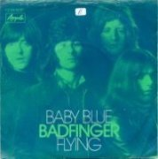 |  | PS  PS | 10.03.1972 | Badfinger | Baby Blue (remix)  Flying | WDRN  Badfingers Apple career seems to have taken a tumble at this point and Apple 42 although apparently destined for a new Badfinger release was scrapped. Baby blue was issued on the album Straight Up whereas the B side was not released in the UK until the 1990's Re-issue of Straight Up where it appeared as a bonus track.
43 | 1C006-93 568  Apple Label A1  Musterplatte  1C006-93 568 | 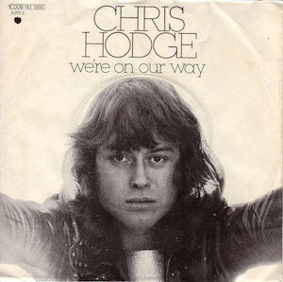 |  | PS  MS | 09.06.1972 | Chris Hodge | We're On Our Way  Supersoul | Another underated and underpromoted singer who was briefly signed to the Apple label. He only issued one single in the UK and two in the USA the second of which Goodbye Sweet Loarraine / Contact love has remained unreleased in any format in the UK, as there was no Apple album issued on which these tracks could have been issued as bonus tracks. Both sides of this single were written by Chris and produced by Tony Cox, who was Yoko's first husband. Issued in a picture sleeve.
44 | 1C006-94 051 |  |  | AS | 24.11.1972 | Sundown Playboys | Saturday Night Special  Valse De Soleil Coucher (Sundown Waltz) | This is one of the most obscure records to be issued on the label. The band are French Canadians and sing the songs in an odd cajun style with French Canadian lyrics. One of the rarest Apple singles ever issued is a 10 inch 78RPM style record of this single. Issued in a picture sleeve.
45 | Not issued |  |  |  | 08.12.1972 | Elephant's Memory | Power Boogie  Liberation Special | John Lennon introduced the Elephants Memory to Apple and appeared on this single and their Apple album too. Produced by John and Yoko, this single appeared with yet another label variant. This time both sides of the record had green Apple labels. Issued in a plain Apple sleeve.
46 | Not issued |  |  |  | 09.03.1973 | Lon & Derrek Van Eaton | Warm Woman  More Than Words | Yet another one off release for Apple, this time two brothers issued a single and an album in the UK and a second single Sweet music / Song of songs in the USA. This single Apple's first of the new year was issued in a now hard to find picture sleeve.
47 | Not issued |  |  |  | 00.04.1973 | John Lennon & Plastik Ono Band | Yang Yang (Yoko Ono)  You Know My Name (Look Up The Number) | WDRN  The A-side of this latest Yoko single was lifted from the album Approximate Infinate Universe, while the B-side remained only issued on the single unitl the Walking on thin ice compilation album which came out in 1992. Issued in a plain Apple sleeve.
47 | Not issued |  |  |  | 04.05.1973 | Yoko Ono | Death Of Samantha  Yang Yang | The A-side of this latest Yoko single was lifted from the album Approximate Infinate Universe, while the B-side remained only issued on the single unitl the Walking on thin ice compilation album which came out in 1992. Issued in a plain Apple sleeve.
48 | Not issued |  |  |  | 09.11.1973 | Yoko Ono | Run, Run, Run  Men, Men. Men | Yoko's last single issued by Apple , both sides were written and produced by Yoko. Only issued in the UK as a single. Issued in a plain Apple sleeve.
49 | Not issued |  |  |  | 08.03.1974 | Badfinger | Apple Of My Eye  Blind Owl | The end of an era. APPLE49 is the last non-Beatle single ever to be issued on Apple, although there was an EP issued in the 1990's. Ironically entitled Apple of my eye, Badfinger's last single on Apple made little impact on the charts and thus ended their relationship with the label. Issued in a plain Apple sleeve.
Apples 1001 | 1C006-90 719  Apple Label A1 |  |  | AS | 24.10.1969 | John Lennon  Yoko Ono | Cold Turkey  Don't Worry, Kyoko (Mummy's Only Looking For A Hand In The Snow) | John Lennon seemed to have found another outlet for some of his more outlandish recodings in Yoko. Some of the material they worked on together The Beatles seemed to resist in recording with the only foray into the avant garde experimental music was Revolution 9 on the White album. On this single John and Yoko deal with the subject of coming of drugs cold turkey style. While the B-side is a very odd Ono composition, Kyoko being Yoko's daughter by her first husband film director Tony Cox. Issued in a picture sleeve.
Apples 1002 | Not issued |  |  |  | 05.12.1969 | John Lennon & Plastic Ono Band | You Know My Name (Look Up The Number)  What's The New Mary Jane? | WDRN  The third single from the Plastic Ono Band was due for release on the same day as Badfinger's Come and get it (5th of Dec 1969). However the single was cancelled and never officially released however some demo did survive. The A-side was a Lennon/McCartney song eventually released on the B-side of Let it be. The B-side was a track that the Beatles although mainly John toyed with during the White album.
Apples 1003 | 1C006-91 149  Apple Label | 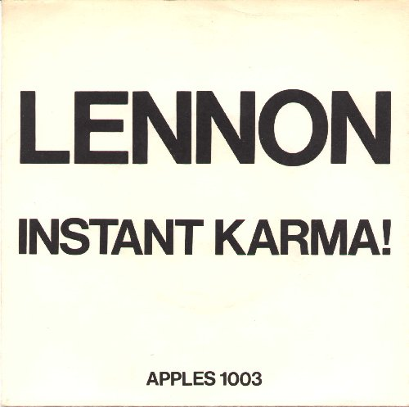 |  | PS | 06.02.1970 | John Lennon  Yoko Ono | Instant Karma! (We All Shine On)  Who Has Seen The Wind? | John Lennon now seemed quite happy to release records without any of the other Beatles being involved, and now with his wife Yoko performing next to him on BBC's Top of the pops it is easy to see why she was blamed for the break up of the group. The A side written by John and produced by Phil Spector who john would collaborate with later on his Rock n Roll album, the B side written by Yoko and produced by John. Issued in a picture sleeve.
 | O 23 910  Black Label  O 23 910  Apple Label A1  O 23 910  Apple Label A1a  mit 7 XBE 50 152 | 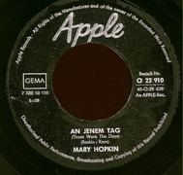 |  | AS |  | Mary Hopkin | An jenem Tag  Turn! Turn! Turn!

