Bestellnummer | ✓ | P | Seite | Interpret | Titel | Cover | Notiz
66 901 |  |  | A1 | Zee, Kathy | Buzzin' |  | 1958
66 901 |  |  | B1 | Zee, Kathy | Crackerjack |  | 1958
66 902 |  |  | A1 | Lane, Rusty | Darling, Goodbye
66 902 |  |  | B1 | Lane, Rusty | Lonely One
66 903 |  |  | A1 | Fabian | Lilly Lou
66 903 |  |  | B1 | Fabian | Be My Steady Date
66 904 |  |  | A1 | Avalon, Frankie | I'll Wait For You
66 904 |  |  | B1 | Avalon, Frankie | Short Fat Fannie
66 905 |  |  | A1 | Ritter, Johnny e i Continentals | Ciao, Ciao, Ciao |  | 1959
66 905 |  |  | B1 | Ritter, Johnny e i Continentals | Va Musica d'Amore
66 906 |  |  | A1 | Alston, Henry | I Dare You Baby
66 906 |  |  | B1 | Alston, Henry | Once In A Beautiful Lifetime
66 907 |  |  | A1 | Fabian | I'm A Man
66 907 |  |  | B1 | Fabian | Hypnotized
66 908 |  |  | A1 | Modugno, Domenico | Piove (Ciao ciao bambina)
66 908 |  |  | B1 | Modugno, Domenico | Resta cu'mme
66 909 |  |  | A1 | Church, Eugene & The Fellows | Pretty Girls Everywhere
66 909 |  |  | B1 | Church, Eugene & The Fellows | For The Rest Of My Life
66 910 |  |  | A1 | Valens, Ritchie | Donna
66 910 |  |  | B1 | Valens, Ritchie | La Bamba
66 911 |  |  | A1
66 911 |  |  | B1
66 912 |  |  | A1
66 912 |  |  | B1
66 913 |  |  | A1 | Avalon, Frankie | Venus
66 913 |  |  | B1 | Avalon, Frankie | I'm Broke
66 914 |  |  | A1 | Modugno, Domenico | Io
66 914 |  |  | B1 | Modugno, Domenico | Farfalle
66 915 |  |  | A1
66 915 |  |  | B1
66 916 |  |  | A1 | Dallara, Tony | Piove
66 916 |  |  | B1 | Dallara, Tony | Conoscerti
66 917 |  |  | A1 | Modugno, Domenico | O Cangaceiro
66 917 |  |  | B1 | Modugno, Domenico | Notte, lunga Notte
66 918 |  |  | A1 | Valens, Ritchie | Ooh My Head
66 918 |  |  | B1 | Valens, Ritchie | Little Girl
66 919 |  |  | A1
66 919 |  |  | B1
66 920 |  |  | A1
66 920 |  |  | B1
66 921 |  |  | A1
66 921 |  |  | B1
66 922 |  |  | A1
66 922 |  |  | B1
66 923 |  |  | A1
66 923 |  |  | B1
66 924 |  |  | A1
66 924 |  |  | B1
66 925 |  |  | A1 | Modugno, Domenico | Libero | PC | 1960
66 925 |  |  | B1 | Modugno, Domenico | Romantica | PC | LC +
66 926 |  |  | A1 | Drami, Arrah | Wa-Ef Chudni
66 926 |  |  | B1 | Drami, Arrah | Aman Doctor
66 927 |  |  | A1 | Modugno, Domenico | Olympia
66 927 |  |  | B1 | Modugno, Domenico | Nel bene e nel male
66 928 |  |  | A1 | Lorne, Lesley | Take All My Love | PC
66 928 |  |  | B1 | Lorne, Lesley | Ritroviamoci (Till We Meet Again) | PC
66 929 |  |  | A1 | I Campioni | Ciao Baby Ciao
66 929 |  |  | B1 | I Campioni | La vita è colorata
66 930 |  |  | A1 | Bindi, Umberto | Il nostro concerto
66 930 |  |  | B1 | Bindi, Umberto | Un giorno, un mese, un anno
66 931 |  |  | A1 | Blanco, Hugo | Orquidea
66 931 |  |  | B1 | Blanco, Hugo | Moliendo Café
66 932 |  |  | A1 | Tobin Mathews Orchestra | Ruby Duby Du |  | 1961
66 932 |  |  | B1 | Tobin Mathews Orchestra | Leatherjacket Cowboy
66 933 |  |  | A1 | Trio "Los Gauchos" | Madre Mia |  | 1961
66 933 |  |  | B1 | Trio "Los Gauchos" | Mona Lisa
66 934 |  |  | A1 | Kaempfert, Bert | Now And Forever
66 934 |  |  | B1 | Kaempfert, Bert | Only Those In Love
66 935 |  |  | A1
66 935 |  |  | B1
66 936 |  |  | A1 | Arab, Guy | Oui Devant Dieu
66 936 |  |  | B1 | Arab, Guy | Manuela
66 943 |  |  | A1 | Edelhagen, Kurt | Isoisän Olkihattu
66 943 |  |  | B1 | Zacharias, Helmut | Säkkijärven polkka
66 945 |  |  | A1 | Los Espanoles | Espanola
66 945 |  |  | B1 | Los Espanoles | Artadecer de un domingo
66 946 |  |  | A1 | Los Espanoles | La Vaca Vieja
66 946 |  |  | B1 | Los Espanoles | Nylon Con Coco
66 947 |  |  | A1 | Hill, Dan, Augmented Orchestra | Oh you beautiful doll
66 947 |  |  | B1 | Hill, Dan, Augmented Orchestra | St. Louis blues cha cha
66 950 |  |  | A1 | Blue Chips | Take Another Step |  | 1960
66 950 |  |  | B1 | Blue Chips | A Song And A Prayer
66 951 |  |  | A1 | Skyliners | Pennies From Heaven |  | 1960
66 951 |  |  | B1 | Skyliners | I'll Be Seeing You
66 952 |  |  | A1 | Bryant, Boudleaux | Hot Spot |  | 1960
66 952 |  |  | B1 | Bryant, Boudleaux & Sparks | Touche
66 953 |  |  | A1 | Valente, Caterina | The Breeze And I |  | 1960
66 953 |  |  | B1 | Valente, Caterina | Side By Side
66 954 |  |  | A1 | Townsel Sisters | Will I Ever |  | 1960
66 954 |  |  | B1 | Townsel Sisters | I Know
66 955 |  |  | A1 | Zang, Tommy | Every Hour, Every Day |  | 1961
66 955 |  |  | B1 | Zang, Tommy | I'm Gonna Slip You Offa My Mind
66 956 |  |  | A1 | Lorne, Lesley | We're Gonna Dance |  | 1960
66 956 |  |  | B1 | Lorne, Lesley | Bloodshot Eyes
66 957 |  |  | A1 | Zang, Tommy | Hey, Good Lookin' |  | 1961
66 957 |  |  | B1 | Zang, Tommy | With Love (For You)
66 958 |  |  | A1 | Dane, Norman | Girls Of Copenhagen
66 958 |  |  | B1 | Dane, Norman | Canale Grande
66 959 |  |  | A1 | Melson, Joe | What's The Use |  | 1961
66 959 |  |  | B1 | Melson, Joe | Oh Yeah
66 960 |  |  | A1 | Zang, Tommy | Take These Chains From My Heart |  | 1961
66 960 |  |  | B1 | Zang, Tommy | Truly, Truly
66 961 |  |  | A1 | Melson, Joe | Hey, Mr. Cupid |  | 1961
66 961 |  |  | B1 | Melson, Joe | No One Really Cares
66 963 |  |  | A1 | Lester, Robie | Ballad Of Cheatin' John |  | 1961
66 963 |  |  | B1 | Lester, Robie | Miracle Of Life
66 964 |  |  | A1 | Lord Roosevelt | Lilian |  | 1961
66 964 |  |  | B1 | Lord Roosevelt | My Music Teacher
66 965 |  |  | A1 | Crazy Otto | Have You Ever Been Lonely
66 965 |  |  | B1 | Crazy Otto | Piano Choo-Choo
66 966 |  |  | A1 | Vintage Jazz Band | Floral Dance
66 966 |  |  | B1 | Vintage Jazz Band | Saratoga-Swing
66 967 |  |  | A1 | Thompson, Sue | Sad Movies
66 967 |  |  | B1 | Thompson, Sue | Throwin' Kisses
66 970 |  |  | A1 | Rusty & Doug (Kershaw) | Hey Mae
66 970 |  |  | B1 | Rusty & Doug (Kershaw) | Sweet Thing
66 972 |  |  | A1 | Carney, Tom | Bettina Song
66 972 |  |  | B1 | Carney, Tom | Make Up
66 973 |  |  | A1 | Thompson, Sue | Norman
66 973 |  |  | B1 | Thompson, Sue | Never Love Again
66 974 |  |  | A1 | Salvo, Sammy | French Poodle |  | 1962
66 974 |  |  | B1 | Salvo, Sammy | Billy Blue
66 975 |  |  | A1
66 975 |  |  | B1
66 976 |  |  | A1 | Thompson, Sue | Two Of A Kind
66 976 |  |  | B1 | Thompson, Sue | It Has To Be Me
66 977 |  |  | A1 | Zang, Tommy | I Can't Hold Your Letters (In My Arms)
66 977 |  |  | B1 | Zang, Tommy | She's Getting Married
66 978 |  |  | A1 | Kaempfert, Bert | That Happy Feeling
66 978 |  |  | B1 | Kaempfert, Bert | Take Me
66 979 |  |  | A1 | Thompson, Sue | If The Boy Only Knew
66 979 |  |  | B1 | Thompson, Sue | Have A Good Time
66 980 |  |  | A1 | Zang, Tommy | Just Call My Name |  | 1962
66 980 |  |  | B1 | Zang, Tommy | I Love You Because
66 981 |  |  | A1 | Kaempfert, Bert | Happy Trumpeter
66 981 |  |  | B1 | Kaempfert, Bert | Tootie Flutie
66 982 |  |  | A1 | Crazy Otto | Alley Cat
66 982 |  |  | B1 | Crazy Otto | Cheerio Choo Choo
66 983 |  |  | A1 | Kaempfert, Bert | Swingin' Safari
66 983 |  |  | B1 | Kaempfert, Bert | Black Beauty
66 984 |  |  | A1 | Folger, Don | There Came A Tear
66 984 |  |  | B1 | Folger, Don | Inside My Heart
66 985 |  |  | A1 | Crazy Otto | Glow Worm
66 985 |  |  | B1 | Crazy Otto | Charmaine
66 986 |  |  | A1 | McCormick Brothers | Red Hen Boogie
66 986 |  |  | B1 | McCormick Brothers | Blue Grass Express
66 987 |  |  | A1 | Thompson, Sue | What's Wrong Bill
66 987 |  |  | B1 | Thompson, Sue | I Need A Harbour
66 988 |  |  | A1 | Kaempfert, Bert | Danke schoen |  | 1963
66 988 |  |  | B1 | Kaempfert, Bert | Give And Take
66 989 |  |  | A1 | Thompson, Sue & Luman, Bob | I Like Your Kind Of Love |  | 1963
66 989 |  |  | B1 | Thompson, Sue & Luman, Bob | Too Hot To Dance
66 990 |  |  | A1 | Taylor, King Size & The Dominoes | Memphis, Tennessee |  | 1964
66 990 |  |  | B1 | Taylor, King Size & The Dominoes | Money
66 991 |  |  | A1 | Shakers | Hippy Hippy Shake
66 991 |  |  | B1 | Shakers | Dr. Feelgood
 |  |  |  | 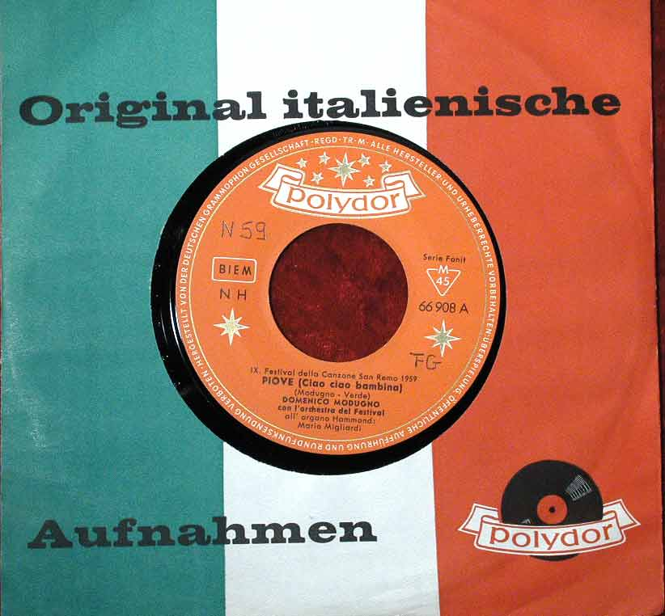 | 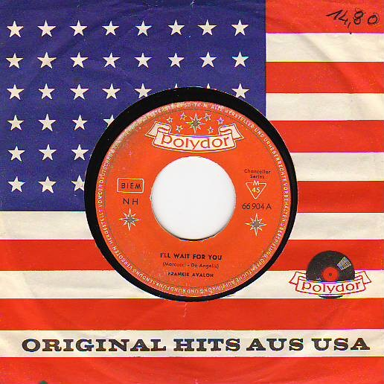
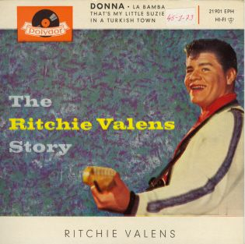
21 901 |  |  | A1 | Valens, Ritchie | Donna | PC
21 901 |  |  | A2 | Valens, Ritchie | La bamba | PC
21 901 |  |  | B1 | Valens, Ritchie | That’s My Little Susie | PC
21 901 |  |  | B2 | Valens, Ritchie | In A Turkish Town | PC
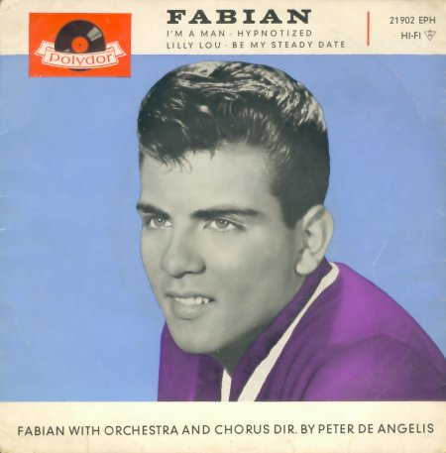
21 902 |  |  | A1 | Fabian | I’m A Man | PC
21 902 |  |  | A2 | Fabian | Hypnotized | PC
21 902 |  |  | B1 | Fabian | Lilly Lou | PC
21 902 |  |  | B2 | Fabian | Be My Steady State | PC
21 903 |  |  | A1 |  |  | PC
21 903 |  |  | A2 |  |  | PC
21 903 |  |  | B1 |  |  | PC
21 903 |  |  | B2 |  |  | PC
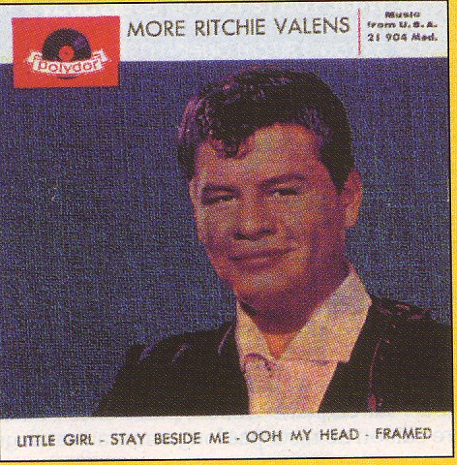
21 904 |  |  | A1 | Valens, Ritchie | Stay Beside Me | PC
21 904 |  |  | A2 | Valens, Ritchie | Little Girl | PC
21 904 |  |  | B1 | Valens, Ritchie | Ooh My Head | PC
21 904 |  |  | B2 | Valens, Ritchie | Framed | PC

